**AN INTERNSHIP REPORT**



**DEPARTMENT OF COMPUTER SCIENCE**

**LOYOLA COLLEGE (AUTONOMOUS)**

**CHENNAI- 600034**

**NAME : A JAI HARISH**

**DEPT. NO : 21-UCS-125**

**INTERNSHIP START : 19.12.2023**

**INTERNSHIP END : 18.01.2024**

**NO. OF DAYS : 30**

**COMPANY NAME : UNIQ TECHNOLOGIES**

**GUIDE NAME : Dr . A. AMALI ASHA**

**DECLARATION**

I am **A JAI HARISH** (Department number: 21-UCS-125) hereby declare that the institutional/internship training report for the partial fulfilment of the degree of B.Sc Computer Science (CS) entitled “**A REPORT ON INTERNSHIP TRAINING UNDERGONE AT UNIQ TECHNOLOGIES** .”, is my original work and this project work has not formed the basis for the Award of any degree associate ship, fellowship or any other similar titles.

**PLACE: CHENNAI SIGNATURE OF THE STUDENT**

**DATE:**

**ACKNOWLEDGEMENT**

First of all, I thank God, for the gift of life and good health which opened a way for me to be able to attend all the internship sessions without any difficulties or interruptions. I thank Loyola College Management, Department Computer Science and institution of Loyola College and specifically principal of Loyola College **Rev. Dr A. LOUIS AROKIARAJ S J ,**  and Deputy Principal

**Dr J.A.CHARLES** for providing me with this great opportunity to experience industrial Life.

I would also like to thank our Head of the Department, **Dr.S.BHARATHIDASON** and our

Co-ordinator **DR .M.D.ANANDA RAJ.** for their support to do my internship. My heartfelt thanks to

**Dr . A. AMALI ASHA.** for accepting my company acceptance letter for internship and updating and encouraging me for internship.

I would really appreciate the efforts and time given by **Miss. Yashika**, to guide me throughout the internship period in online mode. I am really very grateful for his friendly instructions, corrections, innovative ideas and decorum which led to the successful completion of internship period and taught me many life skills.

**TABLE OF CONTENTS**

|  |  |  |
| --- | --- | --- |
| **CHAPTER. NO** | **CONTENTS** | **PAGE.NO** |
| 1 | INTRODUCTION | 5 |
| 2 | COMPANY PROFILE | 6 |
| 3 | SUMMARY OF THE INTERNSHIP | 8 |
| 4 | INTERNSHIP ACTIVITIES | 9 |
| 5 | ASSESSMENT OF THE INTERNSHIP | 11 |
| 6 | CONCLUSION | 12 |
|  | APPENDIX | 13 |
| REFERENCES | 34 |

**1. INTRODUCTION**

This report describes the activities carried out during a period of 30 Days of internship program at **UNIQ TECHNOLOGIES**. The document contains information about the organization and the responsibilities performed throughout the period between 19th December 2022 to 18th January 2024 . More than a plain account of tasks, the objective of this text is to reflect upon the experiences collected during the internship from the perspective of a B. Sc Computer Science Student. The first part of the report offers an overview of the organization, followed by an outline of all duties carried out during this time. Following, it proceeds to describe in some details about the activities and their respective analysis.

The Internship was not on Sundays and there was no Internship on Government Holidays also. The Company had a better infrastructure where it is comfortable to learn new things all about handling the Computer Software Development. The main reason to do my internship here is because of my interest in Software Development. My interest to the Web Development using python started during my college days as it was one of my subjects. My internship has allowed me to learn more about Web development using python practically than theoretically and also the other side of professional work management.

Formal Dress code has been followed at the Internship for every Interns present over there because Dress code is a key factor that defines one’s personality.

**2. COMPANY PROFILE**

**UNIQ TECHNOLOGIES** which provides global web solutions that include web design, web development, hosting of web applications, portals and websites. These services enable you to focus on your core competencies, while we ensure peak performance of your web infrastructure.

**UNIQ TECHNOLOGIES** strives to be a leader in the area of Technical Training's, Products & Research Initiatives. Having developed and established a comprehensive set of sustainable business initiatives that facilitate our bottom-line approach to operating our business.

**UNIQ TECHNOLOGIES** Visions for promoting technical excellence & offering fantastic opportunities to the students and faculty of educational institutes & corporates , enabling them to pursue insight into transformative technical trends with a view to empower & build a knowledge society.

Satisfying a client is a very tough task, but we have not stopped with just satisfying them, but in delighting them in a unique way. A brief look at Pantech's ever-growing client list.

Simply, **UNIQ TECHNOLOGIES** power your services and widen your business prospects with its ability to offer economical and effective e-services with highest integrity and social responsibility.

**ORGANISATION LOGO: -**



**NAME : UNIQ TECHNOLOGIES**

**YEAR OF ESTABLISHMENT : 2007**

**NUMBER OF EMPLOYEES : 15-20**

**ADDRESS : #1 Shifa Arcade, 3rd Floor, Bharathi Nagar 1st**

**Street, N Usman Rd, T. Nagar, Chennai,**

**Tamil Nadu 600017**

**WEBSITE : https://www.uniqtechnologies.co.in/**

**3. SUMMARY OF THE INTERNSHIP**

➢ My internship was done in computer management. In the above company I worked as trainee in web developer.

➢ In the first week I learnt the system Software. During the training session time, I collected information about the Python in web development

➢ I was trained by well experienced staff members. After my training got over, I was given the opportunity to learn the objectives as well as how to do the implementation of the project and the various processes involved in the development of Web Application.

**IMPORTANCE OF INSTITUTIONAL TRAINING:**

The institutional training has educated me on various aspects of the system software. It is really a boon to the student’s community which paves way for the enlightenment and enrichment of knowledge and wisdom. This training imparts to the student’s, the analytical skill for approaching the practical problem in the industry. In addition, it also infuses in a sense of reasoning and responsibilities the minds of intellectuals.

This training serves as a bridge between the theoretical knowledge and the practical implication of the same company. This training helps in bridging the gap between understanding the conceptual knowledge and applying in a practical way.

**4.INTERNSHIP ACTIVITIES**

|  |  |  |
| --- | --- | --- |
| **DATE** | **DAY** | **ACTIVITIES** |
| **19.12.2023** | Tuesday | Introduction about company and introduction to Python |
| **20.12.2023** | Wednesday | Python – Tools | and language characteristics |
| **21.12.2023** | Thusday | Python – Datatypes and Syntaxes |
| **22.12.2023** | Friday | Python- Data structures |
| **23.12.2023** | Saturday | Looping statements in python |
| **24.12.2023** | Sunday | **Holiday** |
| **25.12.2023** | Monday | **Holiday** |
| **26.12.2023** | Tuesday | **Holiday** |
| **27.12.2023** | Wednesday | Classes and objects in python |
| **28.12.2023** | Thusday | Using functions in python |
| **29.12.2023** | Friday | Conditional statements in python |
| **30.12.2023** | Saturday | OOPS concept implementation in python |
| **31.12.2023** | Sunday | **Holiday** |
| **01.01-2024** | Monday | **Holiday** |
| **02.01.2024** | Tuesday | HTML,CSS introduction |
| **03.01.2024** | Wednesday | HTML,CSS Styles,Forms, |
| **04.01.2024** | Thusday | PHP Introduction, XAMMP |
| **05.01.2024** | Friday | PHP functions, Array,Constants, Operator |
| **06.01.2024** | Saturday | PHP Implementation in HTML,CSS |
| **07.01.2024** | Sunday | **Holiday** |
| **08.01.2024** | Monday | Bootstrap introduction |
| **09.01.2024** | Tuesday | MYSQL Introduction ,Workbench |
| **10.01.2024** | Wednesday | MYSQL Aggregate Functions ,Table Creation ,Joints |
| **11.01.2024** | Thusday | MYSQL DDL,DML,DCL,DQL,TCL |
| **12.01.2024** | Friday | MYSQL Classes and Objects |
| **13.01.2024** | Saturday | Bootstrap , Django introduction |
| **14.01.2024** | Sunday | **Holiday** |
| **15.01.2024** | Monday | **Holiday** |
| **16.01.2024** | Tuesday | **PROJECT ASSIGNED** |
| **17.01.2024** | Wednesday | **PROJECT ASSIGNED** |
| **18.01.2024** | Thusday | **PROJECT SUBMISSION , EVAUATION** |

**5. ASSESSMENT OF THE INTERNSHIP**

In **UNIQ TECHNOLOGIES**, this internship has been an excellent and rewarding experience. I can conclude that there have been a lot I’ve learnt from my work at **UNIQ TECHNOLOGIES**. Needless to say, the technical aspects of the work I’ve done are not flawless and could be improved provided enough time. As someone with no prior experience with Machine Learning whatsoever I believe my time spent in research and discovering it was well worth it and contributed to finding an acceptable solution to build a fully functional web service. Two main things that I’ve learned the importance of our time-management skills and self-motivation. Punctuality is one of the main factor that made me uncomfortable in the beginning but later realized that it was a necessary quality factor in life. It was through this that helped the faculties and the students to benefit out of me. And also students were regular at their work.

It was the main factor that helped me to be prepared for the next day’s event, so that I can handle the next day’s class with comfort. Preparations lead me to referencing various text books and surf the internet that was interesting and also made my understanding with ease and impart students with the knowledge what I gained out of it. And also I met people of different age and I had to adapt to their level of understanding and this helped me to improve my communication. I also interacted with the faculties as well thereby gaining the knowledge of skills that they possessed.

It also made me learn the team work, program tackling and situations handling. It also helped me to efficiently work for longer time until I complete the task that was assigned to me. When it comes to a profession, the dress code is a key factor that defines one’s personality. From this internship I learned how to be a professional person by dressing very well adapted to that situation. Usually I used to go in Formal Dress code and it was mandatory for every interns.

**6. CONCLUSION**:

In this internship has been an excellent and rewarding experience. I can conclude that there have been a lot I’ve learnt from my work technically. Needless to say, the technical aspects of the work I’ve done are not flawless and could be improved provided enough time. As someone with no prior experience whatsoever I believe my time spent in development and discovering it was well worth it and contributed to finding an acceptable solution to build a fully functional using **Python ,HTML,CSS, MySql**. Two main things that I’ve learned the importance of our technical solutions and python libraries. It is through writing the report that the maturity and professional experience the student gained as an intern becomes fully realized. It is through the report that the student exercises his critical and analytical faculties and demonstrates newly found skill and identity as a professional communicator.

**APPENDIX:**

PYTHON

INSTALLING BOOTSTRAP:

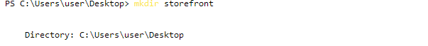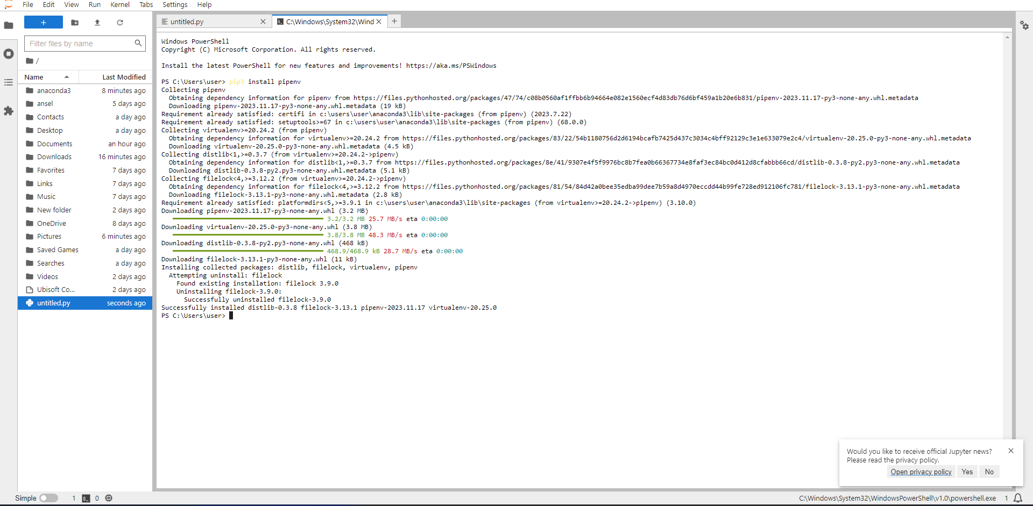

USING ANACONDA NAVIGATOR:

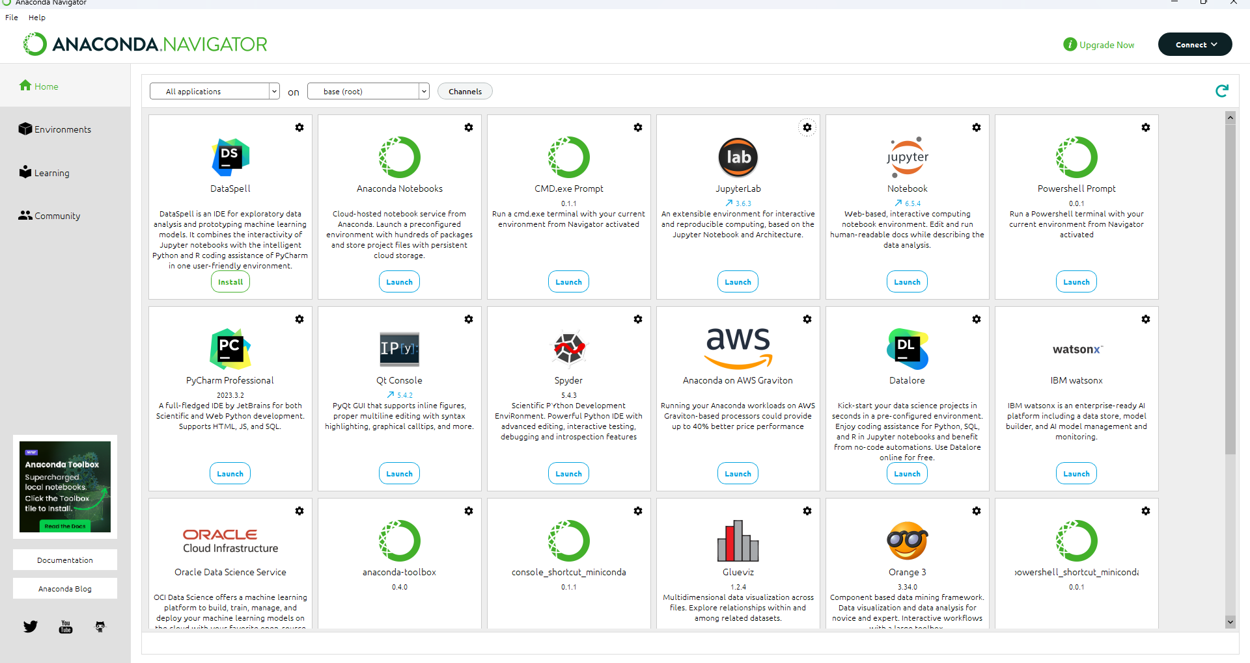

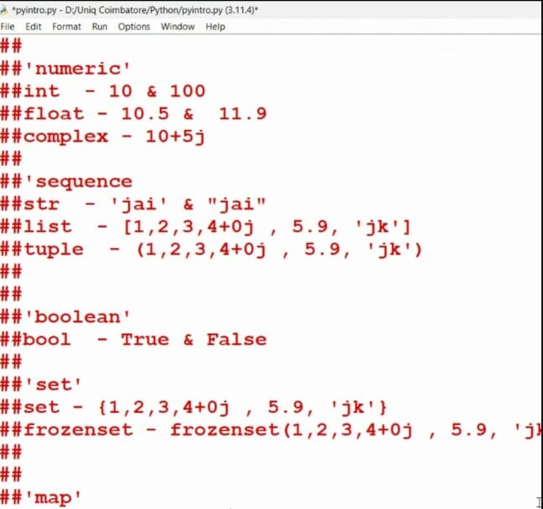

**Using SHELL**

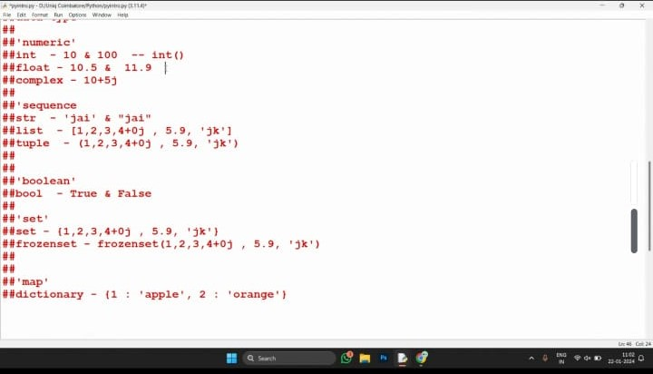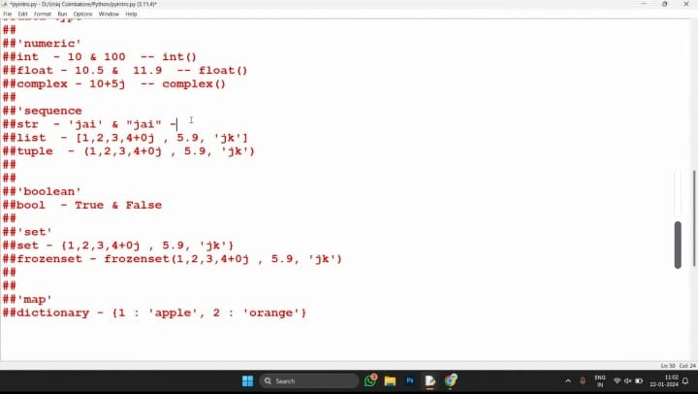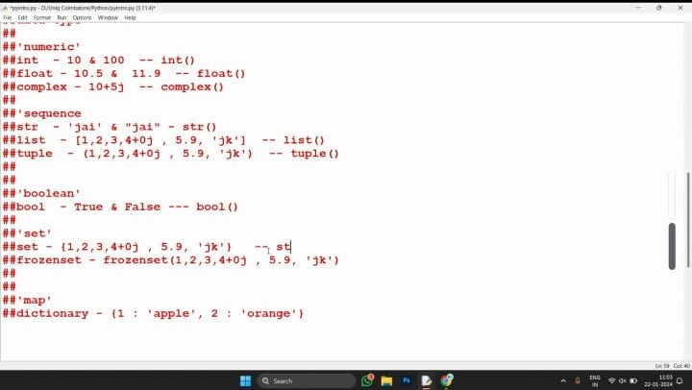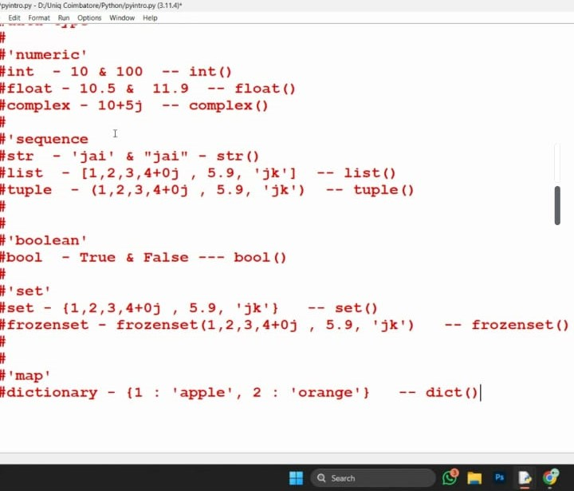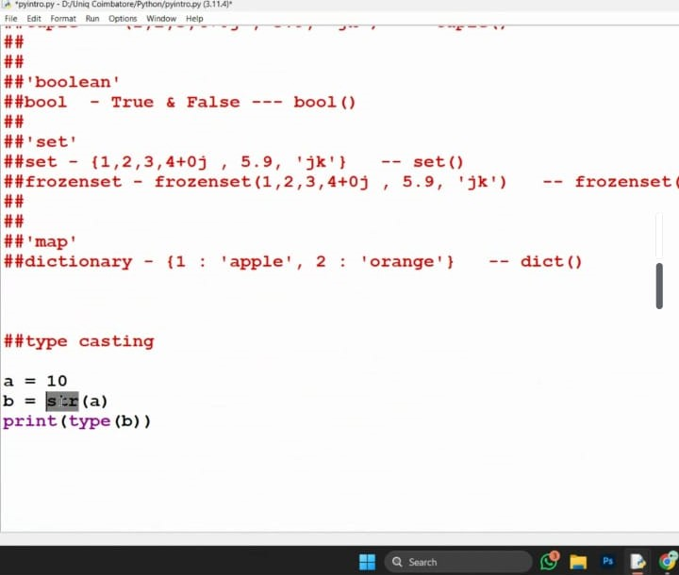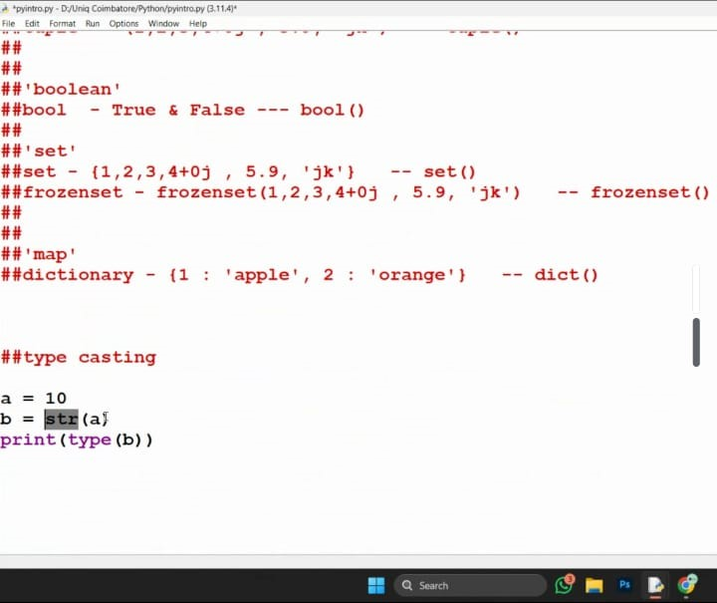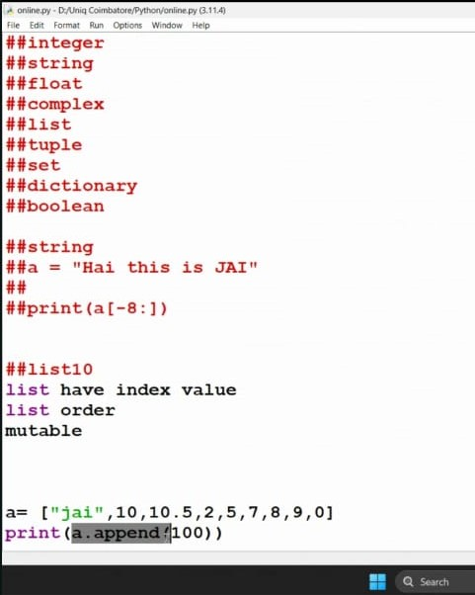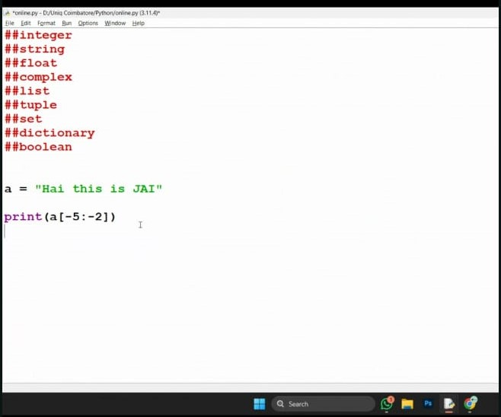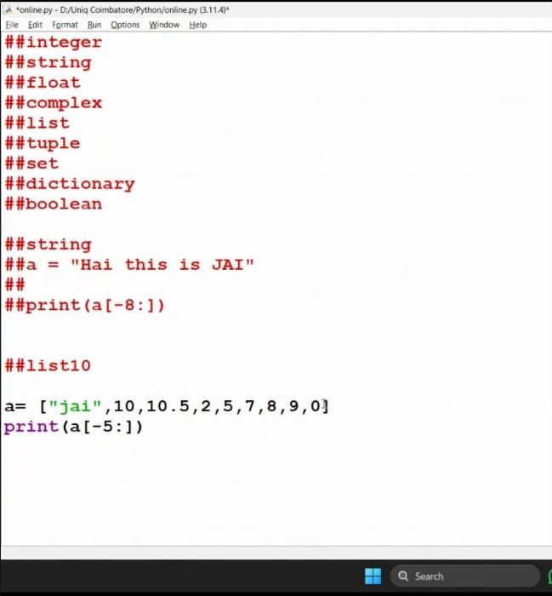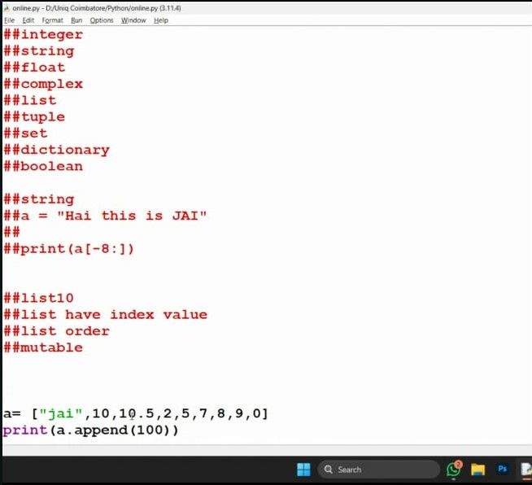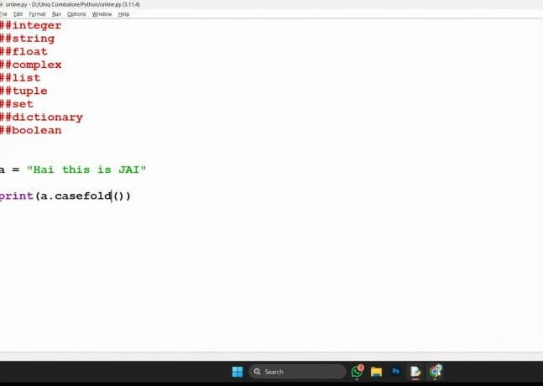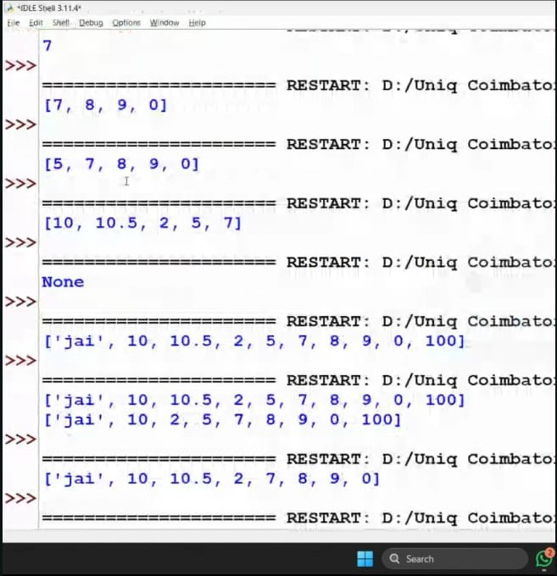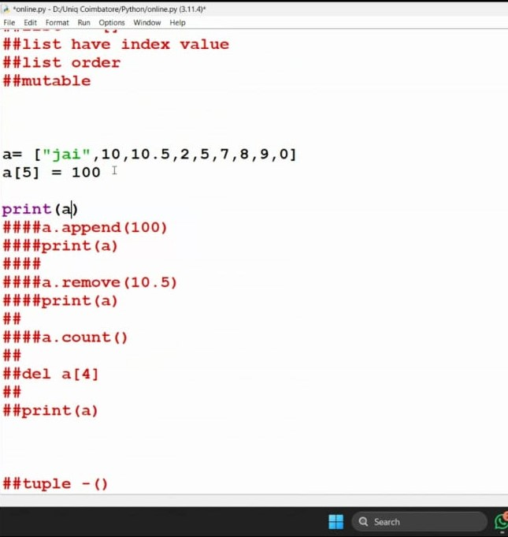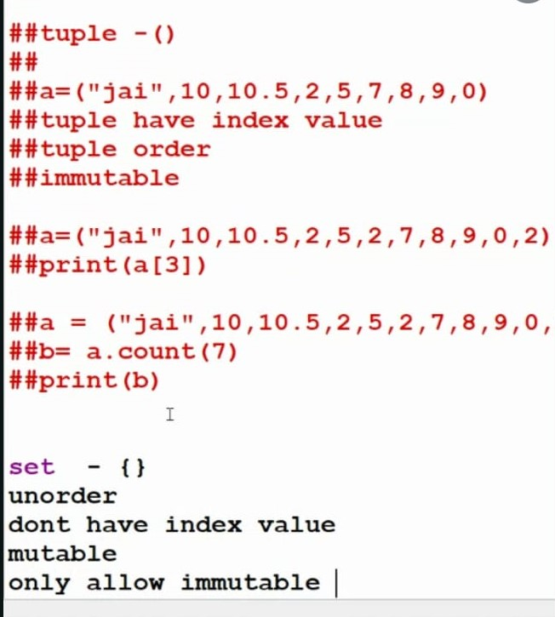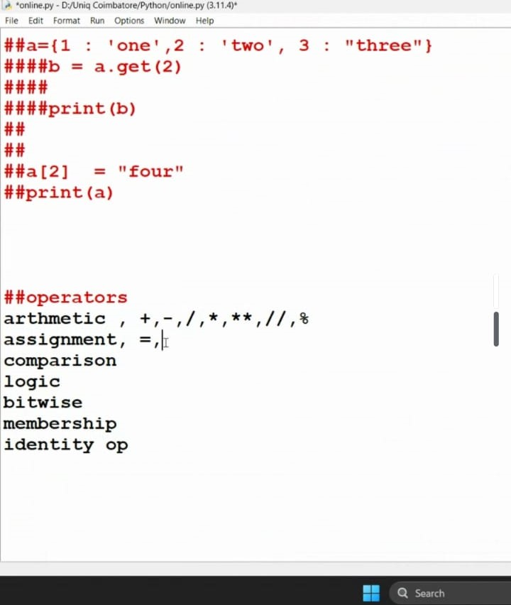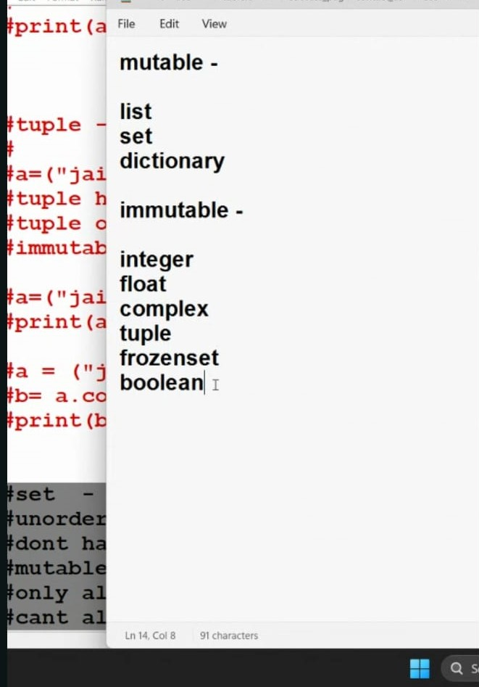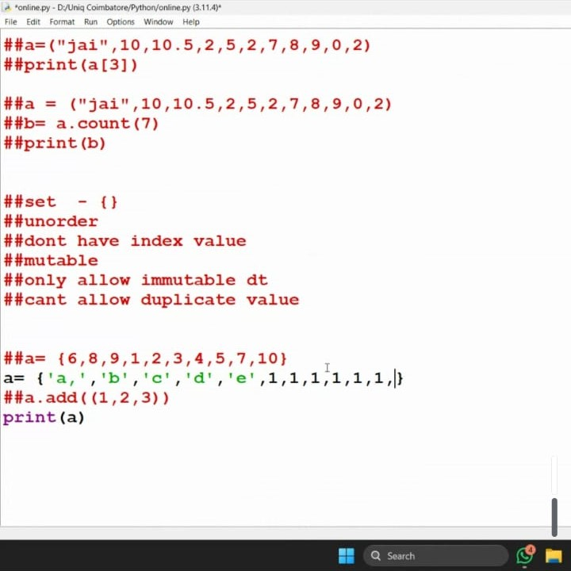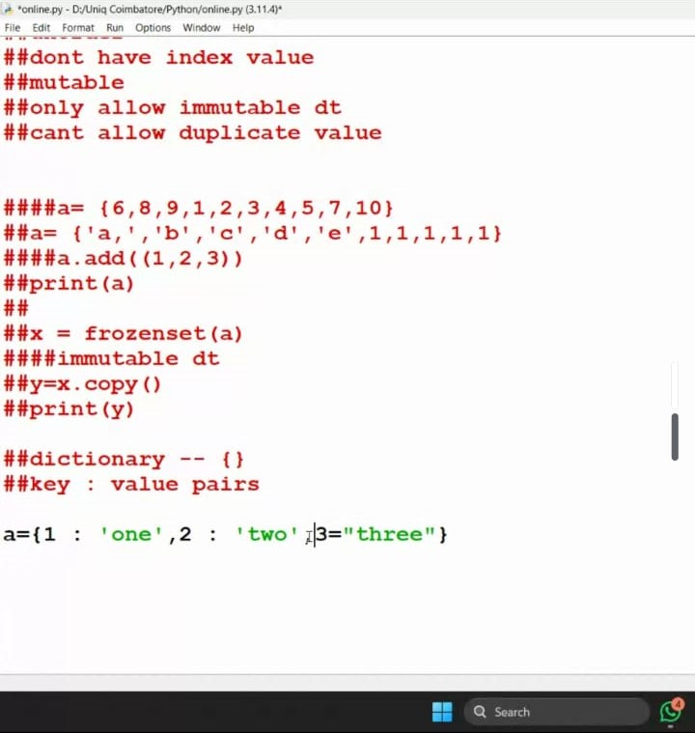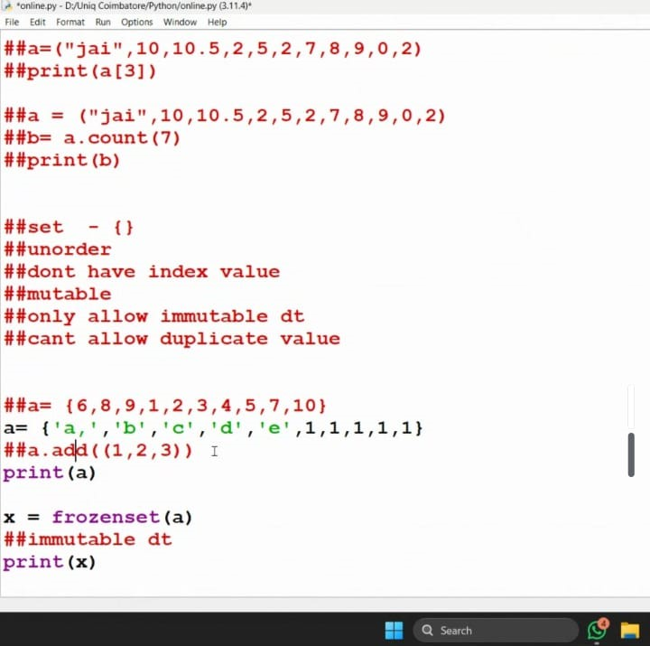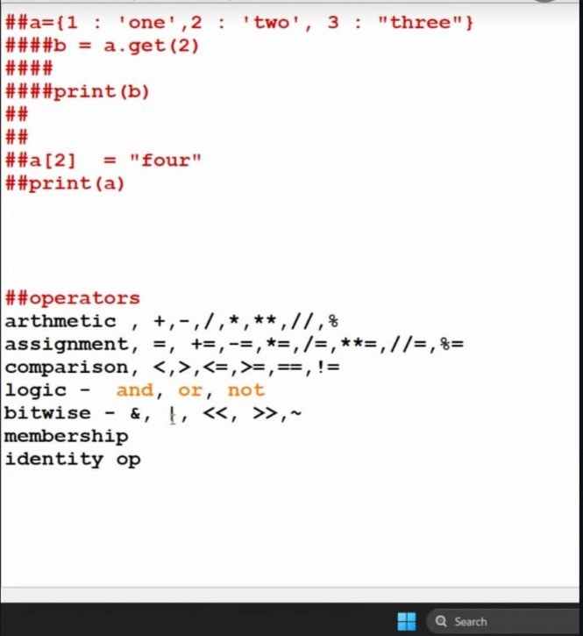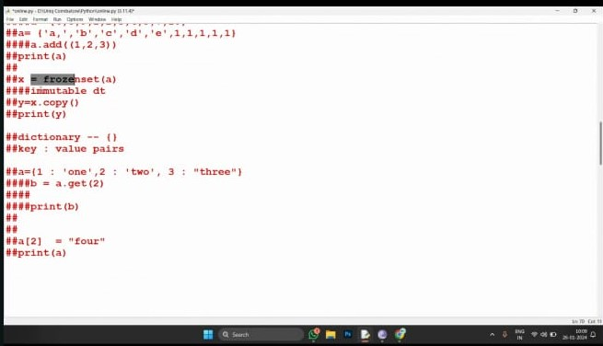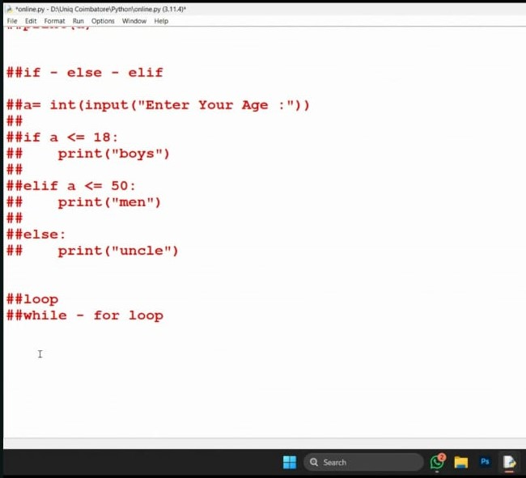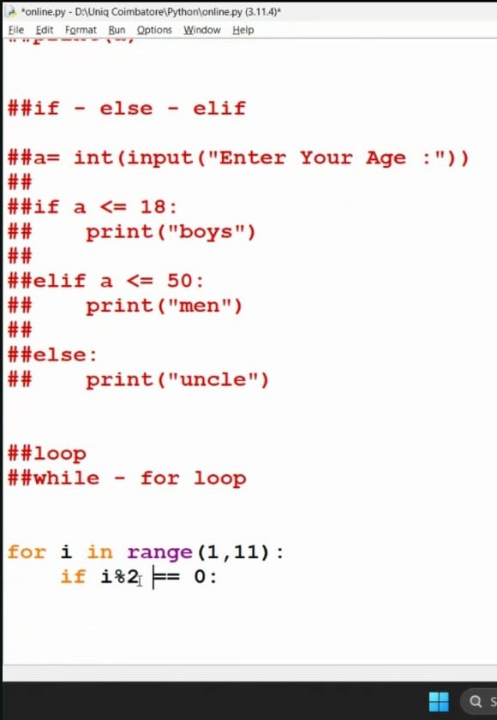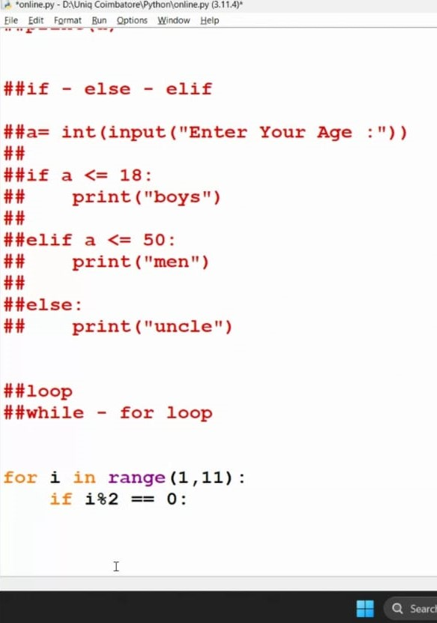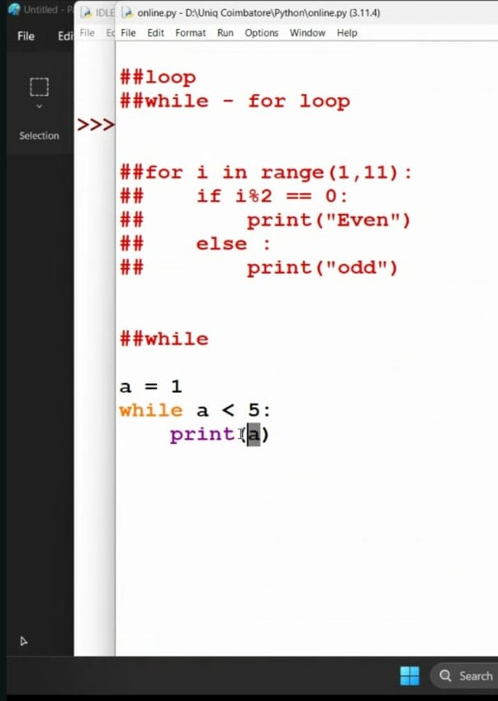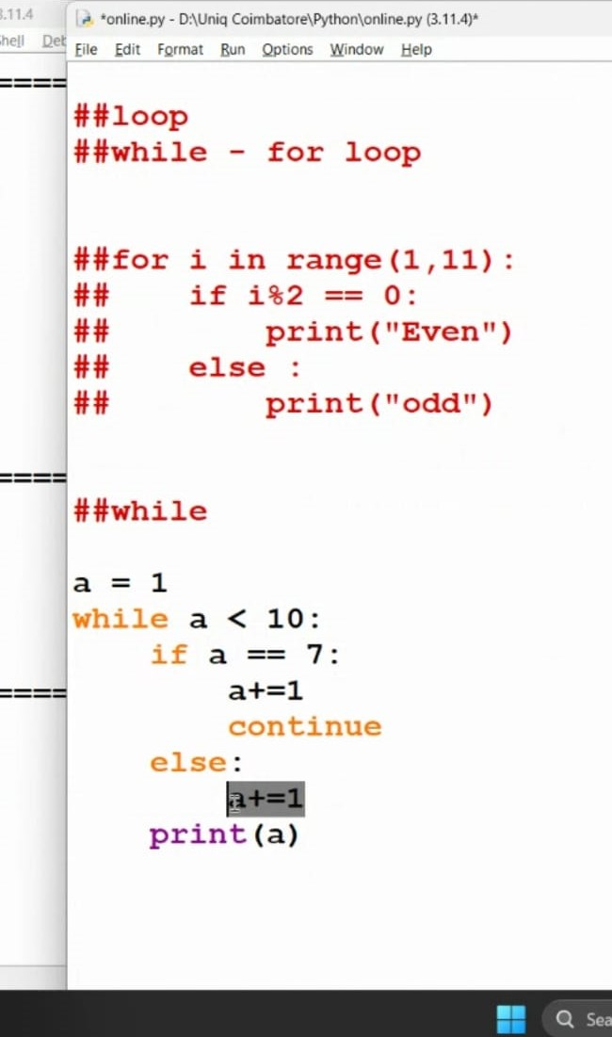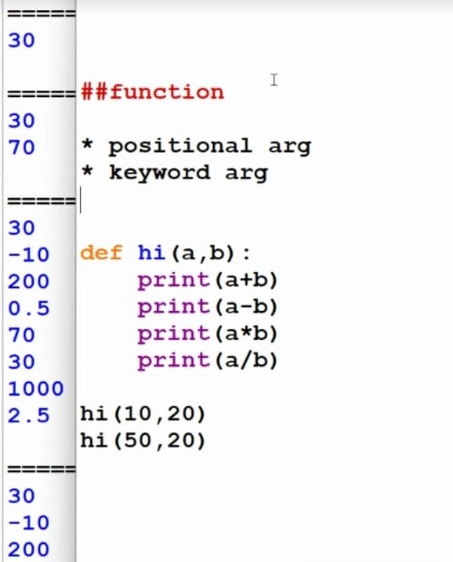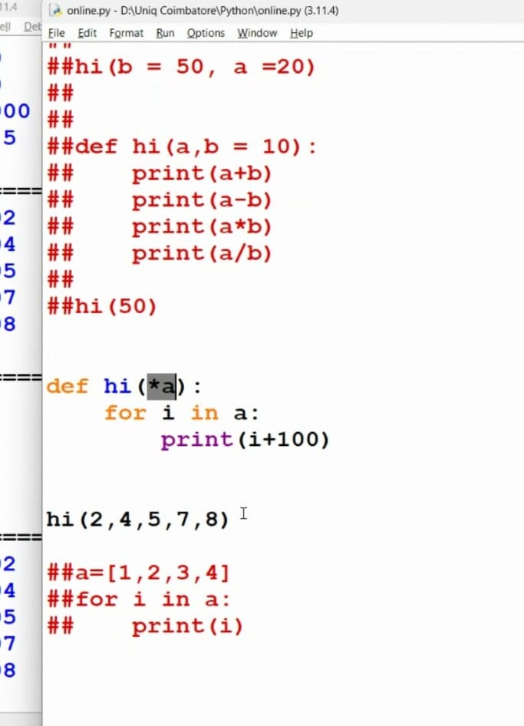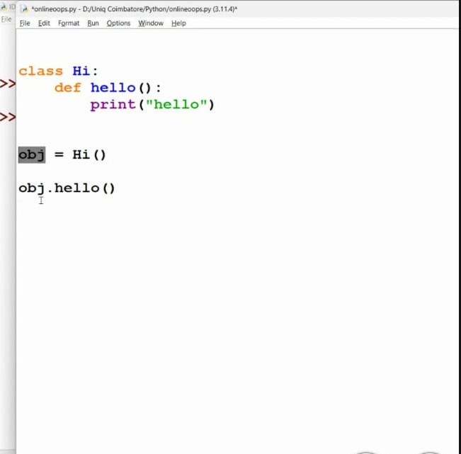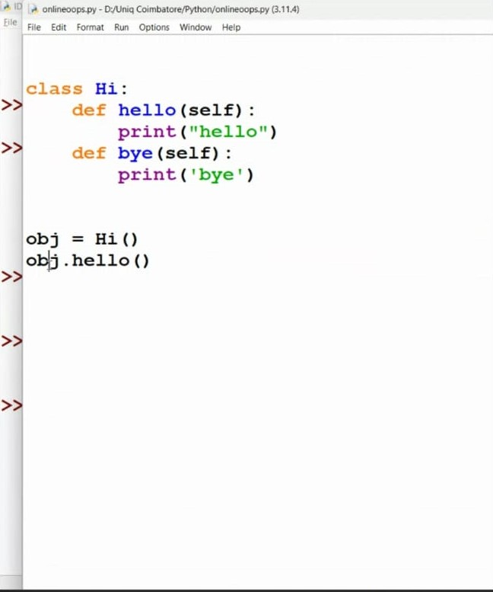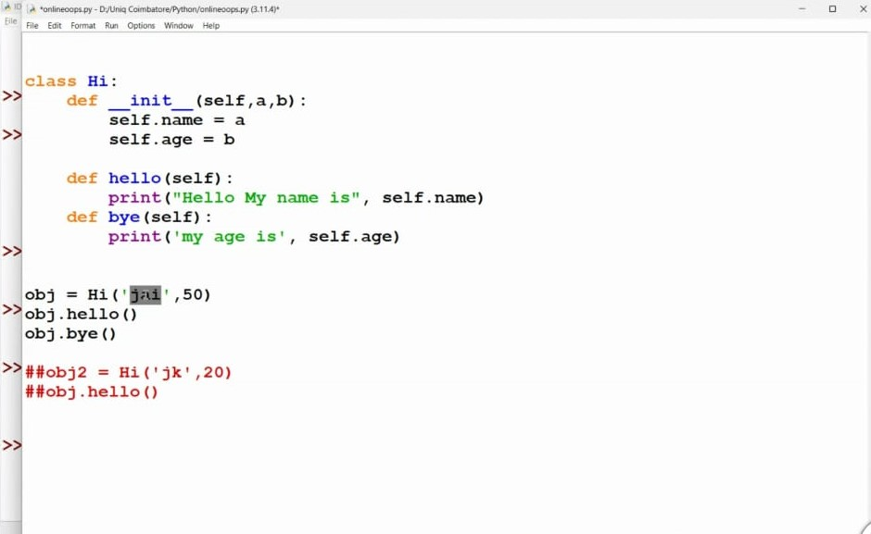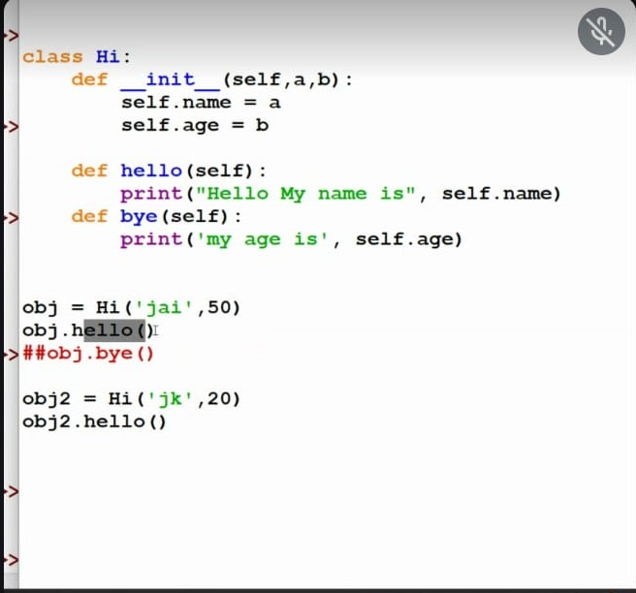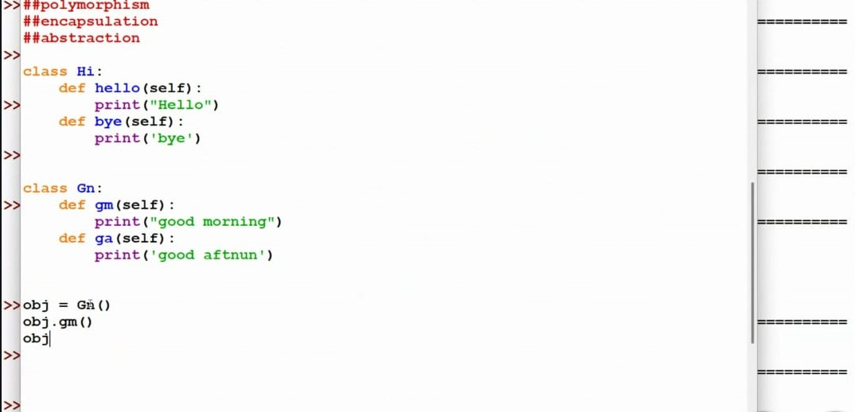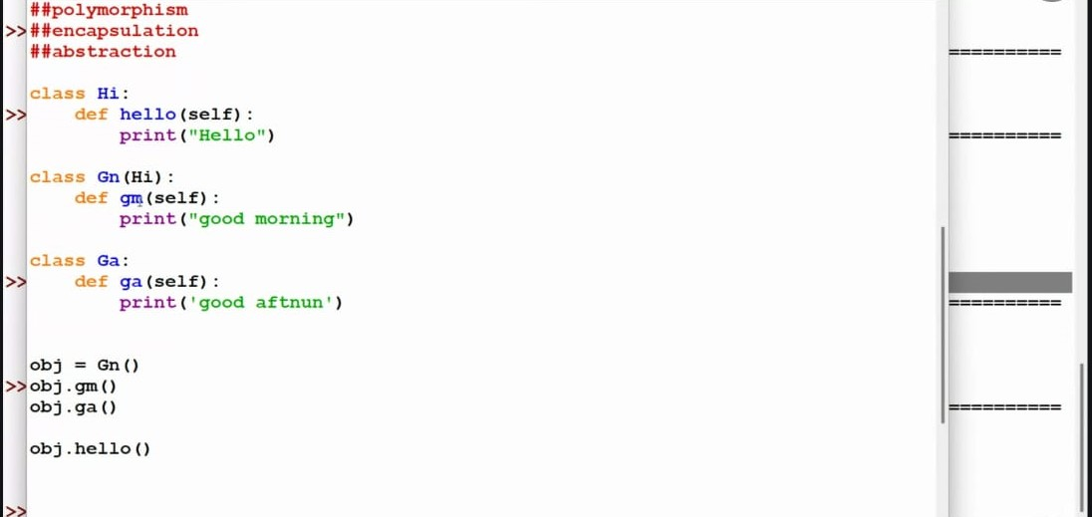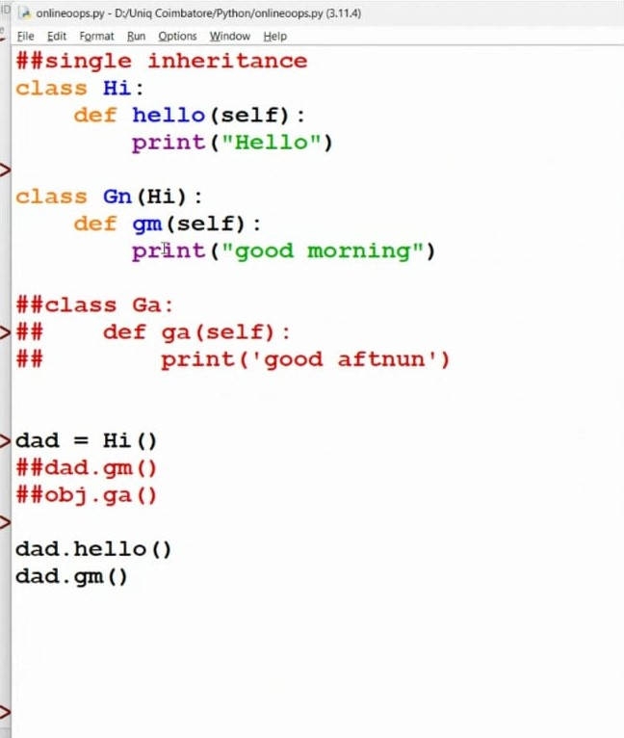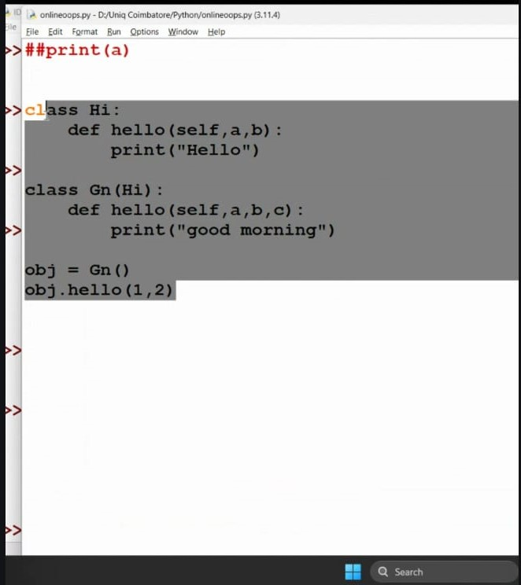

MYSQL

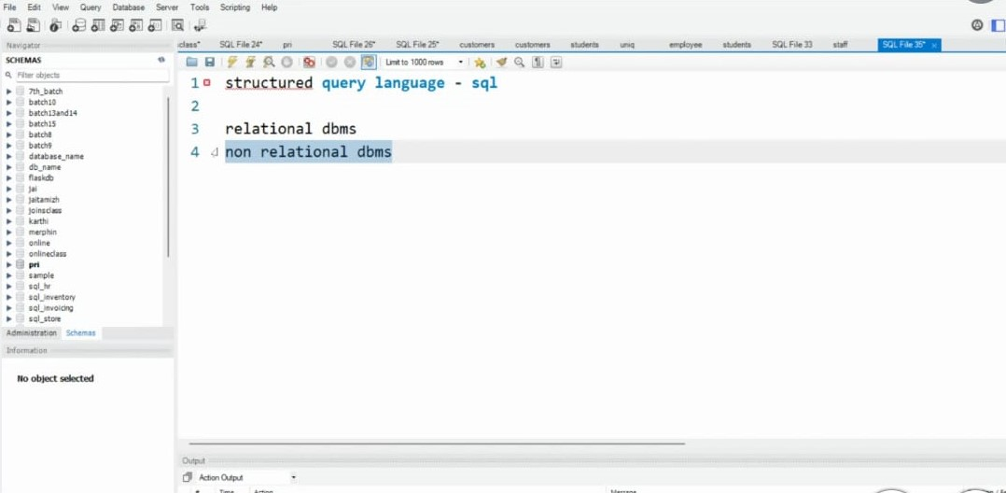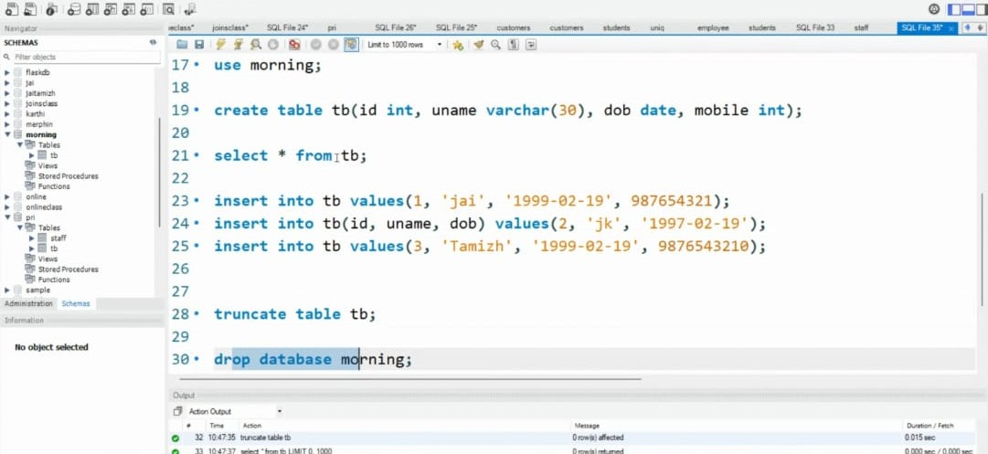

**DJANGO**

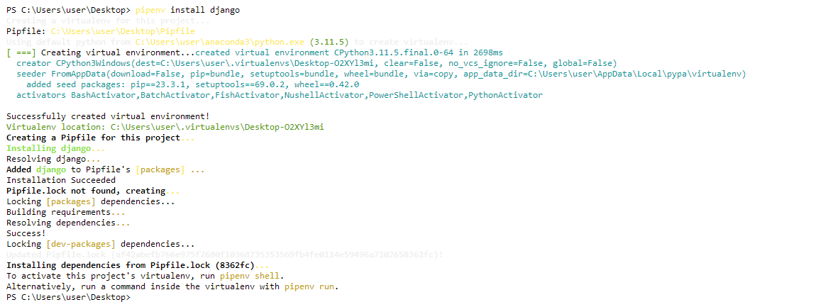

FINAL PROJECT:

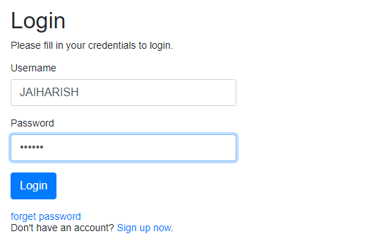

**REFERENCES:**

**Python:**

<https://www.w3schools.com/python/>

**Libraries:**

<https://www.geeksforgeeks.org/libraries-in-python/>

**HTMLCSS:**

<https://www.w3schools.com/html/html_css.asp>

[HTML & CSS Courses & Tutorials | Codecademy](https://www.codecademy.com/catalog/language/html-css)

**MYSQL:**

**https://www.mysqltutorial.org/getting-started-with-mysql/**